**Table Tennis Bat Detection and Best Ball Spot Prediction**

***Minor Project report submitted in***

***partial fulfillment of the requirement for the award of degree of***

# Bachelor of Technology in

**Artificial Intelligence**

***by***

# Mr. Aditya Gupta

# Mr. Aniket Gaikwad

**Mr. Aryan Ambare**

# Mr. Abhishek Warambhe

***Guide***

## Prof. Achamma Thomas

Assistant Professor GHRCE, Nagpur



## Department of Artificial Intelligence

G.H.Raisoni College of Engineering, Nagpur

(An Autonomous Institute affiliated to Rashtrasant Tukadoji Maharaj Nagpur University,Nagpur)

Accredited by NAAC with “A++” Grade (3rd Cycle)

Ranked 163rd by NIRF, in the Engineering Category for India Ranking 2022,

**Nov 2023**

**DECLARATION**

We, hereby declare that the project report titled “**Table Tennis Bat Detection and Best Ball Spot Detection**” submitted herein has been carried out by us for the minor project for the 5th semester. The work is original and has not been submitted earlier as a whole or in part for the award of any degree / diploma at this or any other Institution / University

We also hereby assign to G H Raisoni College of Engineering, Nagpur all rights under copyright that may exist in and to the above work and any revised or expanded derivatives works based on the work as mentioned. Other work copied from references, manuals etc. are disclaimed.

| **Name** | **Mobile_No** | **Email_ID** | **Signature** |
| --- | --- | --- | --- |
| Aditya Gupta | 8767879688 | aditya.gupta.ai@ghrce.raisoni.net |  |
| Aryan Ambare | 9075055849 | aryan.ambare.ai@ghrce.raisoni.net |  |
| Abhishek Warambhe | 9307092472 | abhishek.warambhe.ai@ghrce.raisoni.net |  |
| Aniket Gaikwad | 7058293067 | aniket.gaikwad.ai@ghrce.raisoni.net |  |

**Place: G. H. Raisoni College of Engineering, Nagpur**

**Date: 06 /11/ 2023**

# CERTIFICATE

The project report entitled as “**Table tennis bat detection and best ball spot detection”** submitted by **Aditya Gupta, Aryan Ambare, Abhishek Warambhe and Aniket Gaikwad** for the award of degree for Bachelor of Technology in Artificial Intelligence has been carried out under my supervision.

The work is comprehensive, complete and fit for evaluation.

.

**Prof. Achamma Thomas Prof. Harshita Chourasia Guide Project Incharge**

**Assistant Professor Assistant Professor**

Department of Artificial Intelligence Department of Artificial Intelligence GHRCE, Nagpur GHRCE, Nagpur

**Dr. Mangala Madankar Head**

Department of Artificial Intelligence

GHRCE, Nagpur

`

# ACKNOWLEDGEMENT

We would like to express our profound gratitude to our guide **Prof. Achamma Thomas** for her invaluable guidance. Next, our project in-charge **Prof. Harshita Chourasia** deserves our appreciation for her leadership. We also extend our thanks to our **HOD Dr. Mangala Madankar** and Director **Dr. Sachin Untawale** for creating an excellent academic environment.

Finally, we acknowledge the teaching and non-teaching staff of the Department of Artificial Intelligence for the direct or indirect help given to us in completing this project and for providing consistent encouragement.

We would like to acknowledge that this project was completed entirely by **Aditya Gupta, Aryan Ambare, Abhishek Warambhe** and **Aniket Gaikwad**.

With a deep sense of gratitude.

Projectee Projectee

Signature Signature

**Aditya Gupta Aryan Ambare**

Projectee Projectee

Signature Signature

**Abhishek Warambhe Aniket Gaikwad**

# INDEX

| Sr.No | Title | Pg.no |
| --- | --- | --- |
| 1 | ABSTRACT | 06 |
| 2 | INTRODUCTION | 07 |
| 3 | OBJECTIVES | 08 |
| 4 | LITERATURE SURVEY/STUDY OF EXISTING SOLUTIONS/PRODUCTS | 09 |
| 5 | PROPOSED METHODOLOGY/ SYSTEM ARCHITECTURE | 10-11 |
| 6 | HARDWARE/SOFTWARE SPECIFICATION | 12 |
| 7 | IMPLEMENTATION | 13-17 |
| 8 | CONCLUSION | 18 |
| 9 | REFERENCES | 19 |

# ABSTRACT

Table tennis is a fast-paced sport that demands prediction of the best ball's spot for effective gameplay and training. This research project focuses on the development of an innovative system for table tennis bat detection and ball spot prediction. The proposed system leverages computer vision and machine learning techniques to enhance the accuracy and reliability of ball prediction in real-time, ultimately contributing to an improved gaming experience and training efficiency.

The system comprises two main components: bat detection and ball spot prediction. The bat detection module employs deep learning algorithms and object detection techniques to identify and track the table tennis bat's movement in the playing area. The ball spot prediction module utilizes predictive modeling and clustering technique. Combining these two components enables the system to offer training and gameplay for the table tennis player to improve his reflexes.

This research project's significance lies in its potential to enhance table tennis gameplay and training, providing players and coaches with valuable data and feedback. The system's real-time capabilities open up possibilities for live performance analysis and coaching assistance. Moreover, it can serve as a valuable tool for players to improve their skills, measure their progress, and ultimately elevate their game. The system's applications extend beyond competitive play, making it a versatile tool for both amateur and professional table tennis enthusiasts.

# INTRODUCTION

Table tennis, a dynamic and fast-paced sport, demands a remarkable combination of precision, agility, and quick decision-making from its players. As a game of fractions of seconds, each point in table tennis is defined by split-second reactions, calculated ball placements, and well-timed strokes

This report presents a comprehensive solution for detection and visualizing the movements of a table tennis player and their opponent on a table tennis table. The solution leverages computer vision techniques and user interactions to achieve this goal. It involves three main component Player bat detection, player detection and prediction of best ball spot.

For players to excel in this sport, it is essential to not only develop their physical and technical skills but also to have access to innovative tools and technologies that can assist in honing their performance.

Table tennis (also known as ping-pong) is a racket sport derived from [tennis](https://en.wikipedia.org/wiki/Tennis) but distinguished by its playing surface being atop a stationary table, rather than the court on which players stand. Either individually or in teams of two, players take alternating turns returning a light, hollow ball over the table's net onto the opposing half of the court using small [rackets](https://en.wikipedia.org/wiki/Table_tennis_racket) until they fail to do so, which results in a point for the opponent.

For improving of the skills and reflexes of the table tennis player they should be introduced to the new technologies for that we are creating the model which will predict the spot where to hit the ball as the player should miss the ball from which he will be trained.

This introduces a groundbreaking approach to address this need by utilizing the YOLOv (You Only Look Once version) deep learning model for real-time detection of table tennis bats and the best ball spot. The application of this technology promises to revolutionize table tennis training, analysis, and officiating.

# OBJECTIVES

1. Develop a robust Table Tennis Bat Detection system that accurately tracks the movement and orientation of a player's bat during a match.
2. Develop a Human (player) Detection system that detects the movement of the human(player) during the match.
3. Create a Best Ball Spot Prediction system that can precisely locate the position of the table tennis ball in real time, especially during serves.

# LITERATURE SURVEY/STUDY OF EXISTING SOLUTIONS

| Research Paper | Proposed In | Detection | Techniques | Result |
| --- | --- | --- | --- | --- |
| Table Tennis Ball Spot Prediction using Deep Learning Techniques. | 2020 | Ball Spot Detection in Table Tennis. | Deep Learning, Convolutional neural network, Long Short-term memory. | Achieved accurate ball spot prediction. |
| Vision –Based Table Tennis Ball Trajectory and Prediction. | 2017 | Ball Detection | Computer Vision | Developed a vision –based system for real-time ball tracking and focus on trajectory prediction |
| A Machine Learning Approach for Predicting the Landing Spot of Table Tennis Balls. | 2019 | Ball Spot detection | Machine Learning | Predict the landing spot of table tennis ball with accuracy |
| A vision based Approach to Predict the Bouncing Spot of Table Tennis Balls. | 2017 | Bouncing spot of the ball | Computer Vision | Predict the bouncing spot of table tennis balls using image analysis. |
| Table Tennis Ball Spot Prediction Using CNNs. | 2019 | Ball spot detection | Convolutional Neural Networks | Accurate ball spot prediction through CNNs in Table Tennis. |
| Tracking and Prediction the Landing Point of a Spinning Table Tennis Ball. | 2016 | Detect Spinning of a Ball | Sensor-based Tracking | Predicting the spinning ball landing point improving accuracy |

# PROPOSED METHODOLOGY/ SYSTEM-ARCHITECTURE

**Real-Time Opponent Tracking:**

This component captures real-time video from a camera.

It uses a Pose Detection module to identify and track the opponent's position (x, y coordinates).

The detected opponent's coordinates are continuously updated.

**Coordinate Sharing Mechanism:**

This component is responsible for sharing the real-time opponent's coordinates with other parts of the system.

It could use a messaging system, such as message queues or sockets, to communicate the coordinates to other components.

**Best Spot Prediction:**

This part of the system receives the real-time opponent's coordinates from the Coordinate Sharing Mechanism.

It compares the opponent's coordinates with predefined sample coordinates to find the "best spot" for your application.

It continuously updates the best spot based on the opponent's movements.

**Visualization and User Interaction:**

The system provides a user interface for visualization.

It displays the real-time video feed along with the opponent's and best spot's positions.

It allows user interactions, such as selecting a spot or performing other actions.

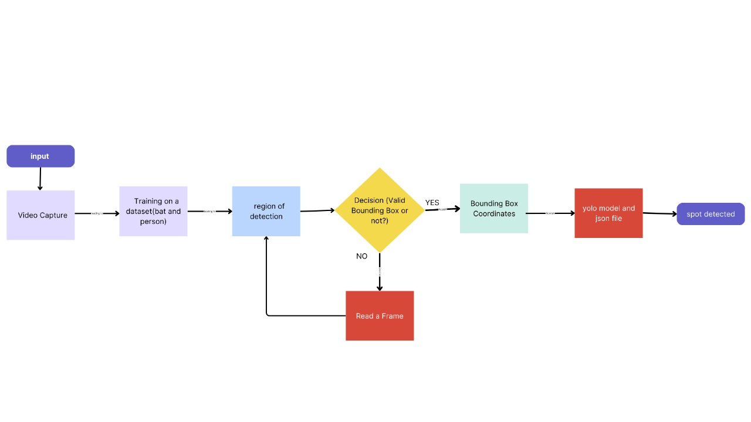**Fig.1 Flowchart**

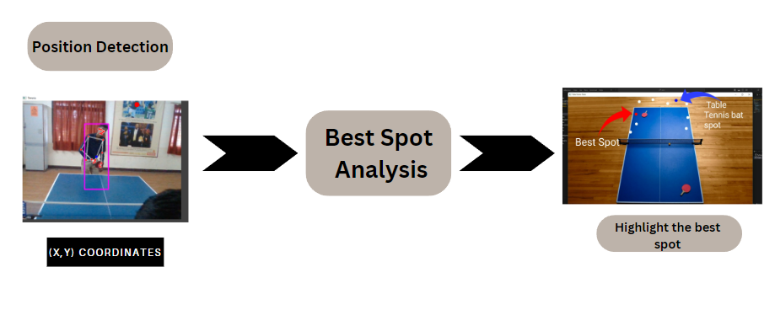**Fig.2 System Architecture**

# HARDWARE / SOFTWARE SPECIFICATION

Hardware:

* CPU: Intel Core i5 or higher
* RAM: 8 GB or higher
* Storage: 256 GB SSD or higher
* GPU: 4 GB minimum

Software:

* Operating System: Windows or Linux
* Programming Language: Python
* Libraries: Cv2, Numpy, json, cvzone, PoseDetector
* Integrated Development Environment (IDE): Jupyter Notebook or PyCharm

# IMPLEMENTATION

In the initial phase of our project, we focus on environment setup. We ensure that Python 3.11 is installed, as well as essential libraries. We utilize pip to install "opencv-python" for image processing and "cvzone" for pose detection. While the instructions mentioned "mediapie," it appears that this library isn't recognized or necessary for our project. In addition, we choose an Integrated Development Environment (IDE) that suits our preferences. We then create a dedicated project folder, "Project_TT," where we will organize our work.

The heart of our project lies in "opponent_posi.py," where we leverage OpenCV and the "cvzone" library to capture and process video frames. We initialize a video capture object for the default webcam, enabling real-time video input. Within a continuous loop, we read frames, detect poses (skeletons) using the "PoseDetector" object, and extract landmark lists ("lmList") and bounding box information ("bboxInfo"). We pay specific attention to the right palm, located at landmark index 17, and print its coordinates when detected.

Our system doesn't stop at just capturing poses. In "opponent_posi.py," we also track the opponent's bat, providing a complete table tennis analysis. When we detect bounding box information, we loop through the data and extract the coordinates of the opponent's bat. These coordinates are printed on the console, allowing us to monitor the bat's position in real-time.

To enhance our project's interactivity, we employ "best_s.py." This component is designed to work with user input. We load an image of a table tennis table, "resize2.jpg," into a named window. Here, we give users the ability to click on the image to identify the opponent's bat position. The program then determines the closest predefined spot on the table corresponding to the user's click. This feature enriches the project by engaging users in the analysis process.

User interaction is made possible through predefined sample coordinates stored in "sample_coordinates.json." This JSON file contains ten sample points, each specifying "user_click" and "best_spot" coordinates. These sample points serve as reference data, allowing the system to find and display the closest predefined spot on the table when a user clicks on the image. This level of customization and interaction greatly enhances the user experience and the project's functionality.

**Code for Bat and Human Detection:**

import cv2

from cvzone.PoseModule import PoseDetector

detector = PoseDetector()

cap = cv2.VideoCapture(0)

while True:

success, img = cap.read()

img = detector.findPose(img)

lmList, bboxInfo = detector.findPosition(img, bboxWithHands=True)

if lmList:

right_palm_x, right_palm_y = lmList[17][1], lmList[17][2]

print(f"Right Palm Coordinates - X: {right_palm_x}, Y: {right_palm_y}")

if bboxInfo:

for bbox in bboxInfo:

if len(bbox) == 4:

x, y, width, height = bbox

print(f"Opponent bat coordinates - X: {x}, Y: {y}")

else:

print(f"Invalid bbox format: {bbox}")

cv2.imshow("Tennis", img)

key = cv2.waitKey(1)

if key == ord('q'):

break

cap.release()

cv2.destroyAllWindows()

**Code for Best Ball Spot Prediction:**

import cv2

import numpy as np

import json

table_tennis_table = cv2.imread("resize2.jpg")

cv2.namedWindow("Table Tennis Table")

markers = []

with open("coordinates.json", "r") as file:

sample_coordinates = json.load(file)

def get_user_coordinates(event, x, y, flags, param):

if event == cv2.EVENT_LBUTTONDOWN:

opponent_bat_position = (x, y)

closest_distance = float("inf")

best_spot = None

for point, coordinates in sample_coordinates.items():

distance = ((opponent_bat_position[0] - coordinates["user_click"][0]) ** 2 +

(opponent_bat_position[1] - coordinates["user_click"][1]) * 2) * 0.5

if distance < closest_distance:

closest_distance = distance

best_spot = coordinates["best_spot"]

for marker in markers:

cv2.circle(table_tennis_table, marker, 10, (255, 255, 255), -1)

markers.clear()

if best_spot is not None:

cv2.circle(table_tennis_table, best_spot, 10, (0, 0, 255), -1)

markers.append(best_spot)

cv2.circle(table_tennis_table, opponent_bat_position, 10, (255, 0, 0), -1)

markers.append(opponent_bat_position)

print("Opponent Bat Position:", opponent_bat_position)

print("Best Spot Coordinates:", best_spot)

cv2.imshow("Table Tennis Table", table_tennis_table)

cv2.setMouseCallback("Table Tennis Table", get_user_coordinates)

cv2.imshow("Table Tennis Table", table_tennis_table)

cv2.waitKey(0)

cv2.destroyAllWindows()

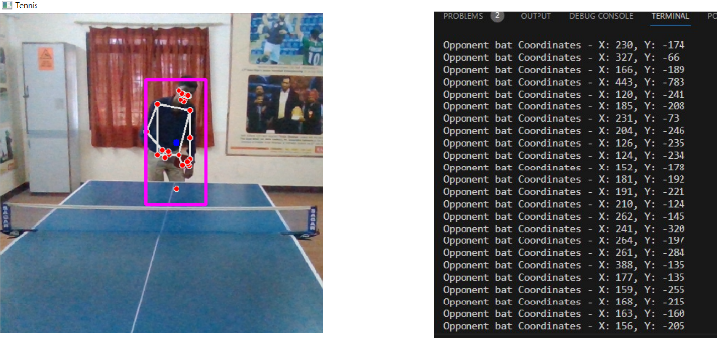

| Fig.3 Output of Table Tennis Bat Detection | Fig.4 Output of Table Tennis Bat Detection |
| --- | --- |
|  |  |

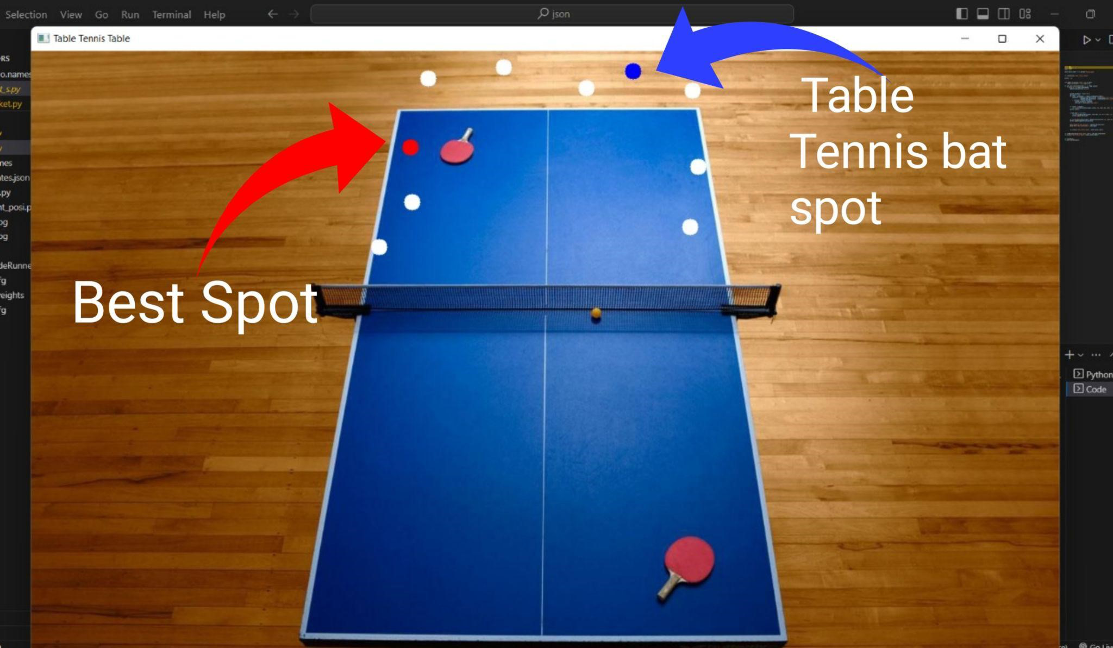

Fig.5 Output of best spot prediction

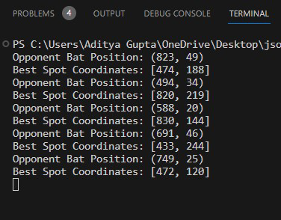

Fig.6 Output Coordinates of best spot

# CONCLUSION

The development of a system that combines the detection of table tennis bats, player positioning, and the identification of areas where players are likely to miss the ball represent a significant step forward in the realm of table tennis technology. This innovative system brings several crucial elements together, contributing to a deeper understanding of player performance and the dynamics of table tennis matches.

By detecting table tennis bats, the system provides insights into player readiness and positioning, allowing for a better understanding of their preparedness to receive and make shots. This information is invaluable for players and coaches seeking to refine their techniques and strategies.

Furthermore, the distinction between the "blue ball spot" and the "red ball spot" offers a unique and insightful perspective on shot precision. The "blue ball spot" identifies the expected player position for an accurate shot, while the "red ball spot" highlights the zones where players are more likely to miss the ball. This feature is a game changer, enhancing the system's ability to provide immediate feedback on player accuracy and helping in the identification of areas that require improvement.

This technology holds the potential to enhance training sessions, automate coaching, and aid referees in making more accurate judgments. It also offers a more engaging and insightful experience for spectators, as they gain a deeper appreciation of the subtleties of the game

# REFERENCES

1. J. Cui, Z. Liu, and L. Xu, “Modelling and simulation for table tennis referee regulation based on finite state machine,” Journal of Sports Sciences, vol. 35, no. 19, pp. 1888–1896, 2017.
2. View at: Publisher Site | Google Scholar
3. S. Tainsky, S. Kerwin, J. Xu, and Y. Zhou, “Will the real fans please remain seated? Gender and television ratings for pre-game and game broadcasts,” Sport Management Review, vol. 17, no. 2, pp. 190–204, 2014.
4. View at: Publisher Site | Google Scholar
5. X. Ning, K. Gong, W. Li, L. Zhang, X. Bai, and S. Tian, “Feature refinement and filter network for person reidentification,” IEEE Transactions on Circuits and Systems for Video Technology, 2020.
6. View at: Publisher Site | Google Scholar
7. W. Cai and Z. Wei, “PiiGAN: generative adversarial networks for pluralistic image inpainting,” IEEE Access, vol. 8, pp. 48451– 48463, 2020.
8. View at: Publisher Site | Google Scholar
9. X. Ning, P. Duan, W. Li, and S. Zhang, “Real-time 3D face alignment using an encoder-decoder network with an efficient deconvolution layer,” IEEE Signal Processing Letters, vol. 27, pp. 1944–1948, 2020.
10. View at: Publisher Site | Google Scholar
11. W. Cai and Z. Wei, “Remote sensing image classification based on a cross-attention mechanism and graph convolution,” IEEE Geoscience and Remote Sensing Letters, 2020.
12. View at: Publisher Site | Google Scholar 1